 Name – Dax Patel

Class- 12 A

Taught by – Shagufa Miss



St Xavier’s High School (Vapi)

Computer Science (083)

Practical list (2023-2024)

|  |  |  |  |
| --- | --- | --- | --- |
| Sr No. | Practical Name | Date | Teacher Sign |
| 1. | Write a program that reads a text file line by line and displays each word separately by a #tag |  |  |
| 2. | Write a program to read a text file and display the count of vowels and consonant in the file |  |  |
| 3. | Write a program to display the size of a file in bytes. |  |  |
| 4. |  |  |  |
| 5. |  |  |  |
|  |  |  |  |
|  |  |  |  |
|  |  |  |  |
|  |  |  |  |
|  |  |  |  |
|  |  |  |  |
|  |  |  |  |
|  |  |  |  |
|  |  |  |  |
|  |  |  |  |

P1) Write a program that reads a text file line by line and displays each word separately by a #tag

Input-

myfile=open("answer.txt","r")

line="" #initially stored a space (a non-None value)

while line:

line=myfile.readline() #one line read from file

#printing the line word by using word split ()

for word in line.split():

print(word, end='#')

print ()

#close the file

myfile.close()

Output-

P2) Write a program to read a text file and display the count of vowels and consonant in the file

Input- filename = input("Enter the file name: ")

with open(filename, 'r') as f:

text = f.read()

vowels = 0

consonants = 0

for i in text:

if i.isalpha():

if i.lower() in ['a', 'e', 'i', 'o', 'u']:

vowels += 1

else:

consonants += 1

print("Number of vowels:", vowels)

print("Number of consonants:", consonants)

Output-

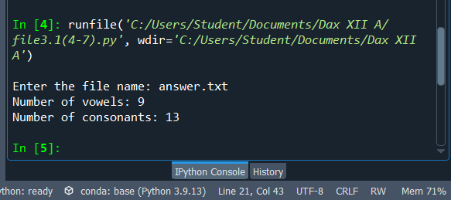

P4) Write a program to display the size of a file in bytes.

Input-